JAVASCRIPT ASSIGNMENT
NAME = M.SAAD
ID = 503244

Chapter#01

TASK #01
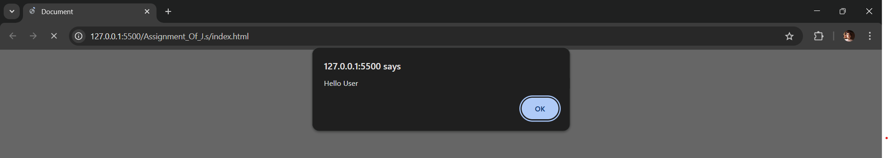

TASK #02
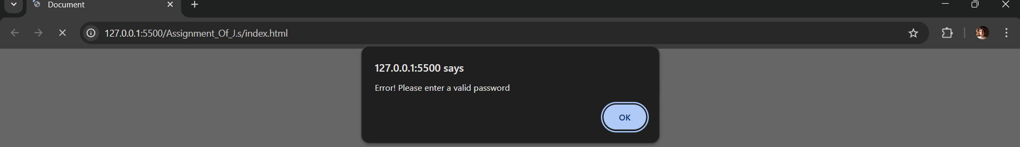

TASK #03
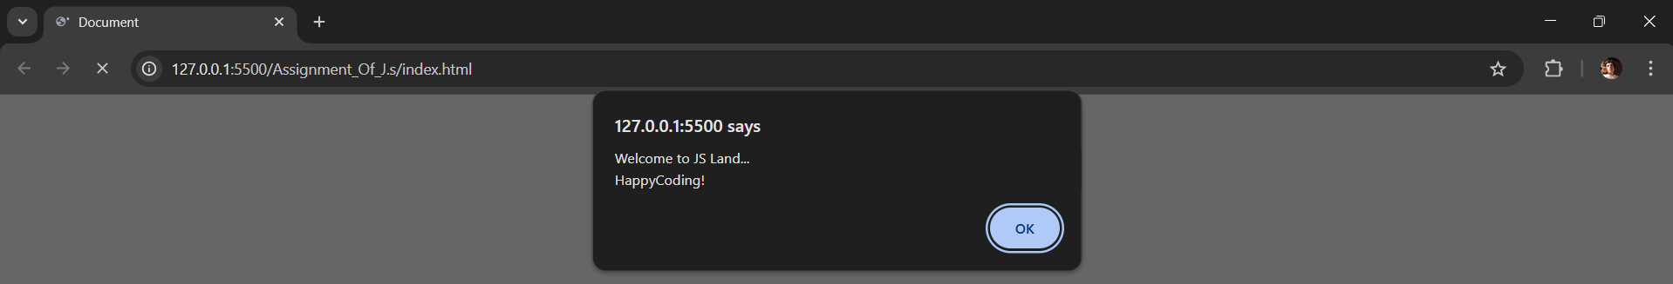

TASK #05
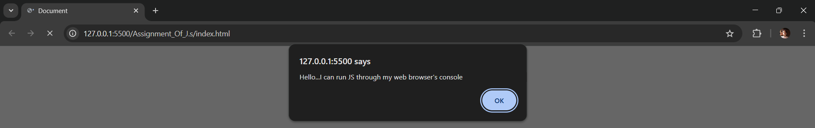

Chapter#02

TASK #01
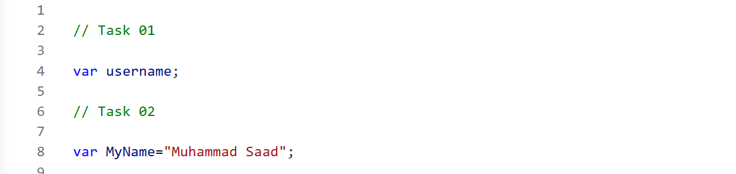

TASK #02


TASK #03
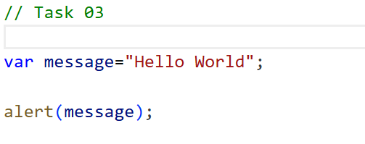

TASK #04
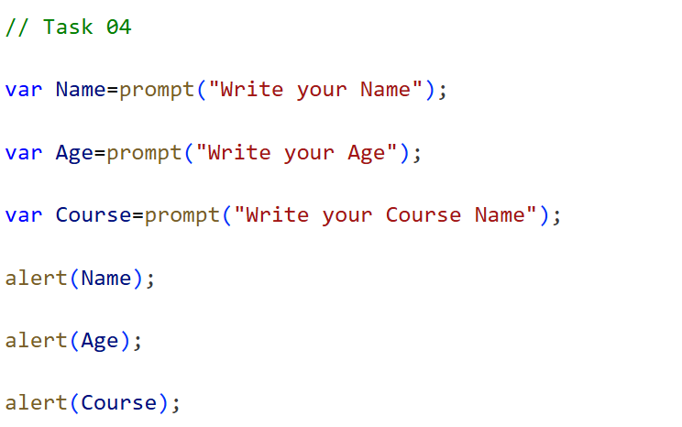

TASK #05
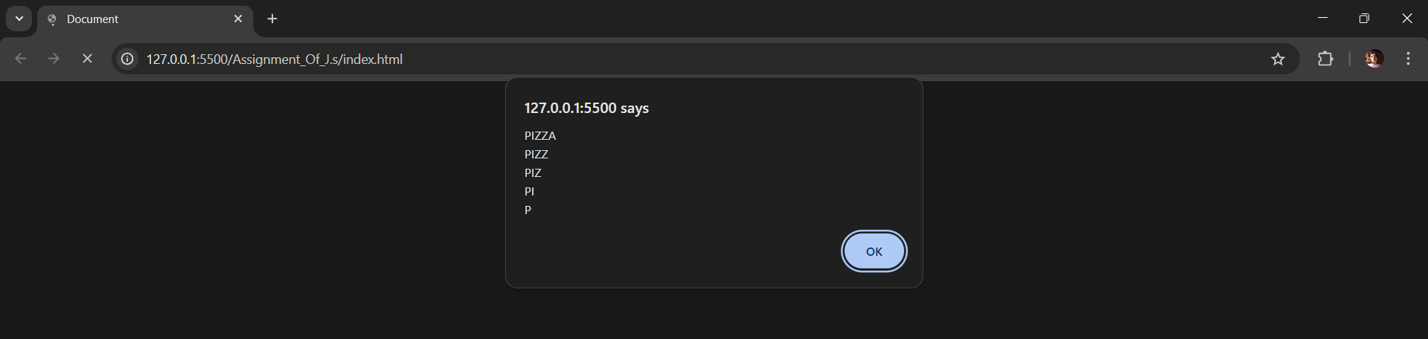

TASK #06
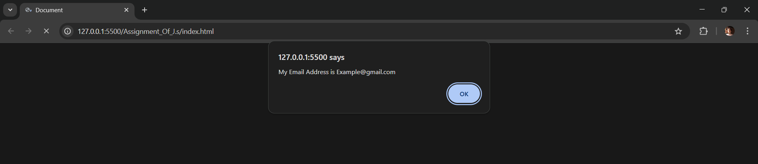

TASK #07
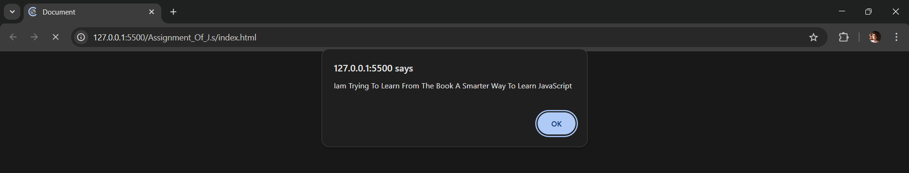

TASK #08
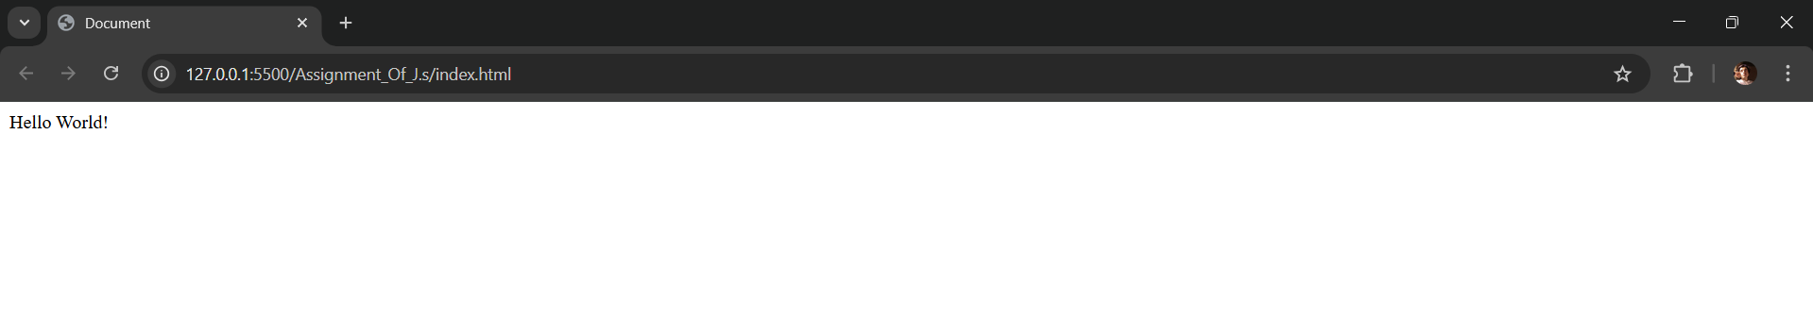

Chapter#03

TASK #01
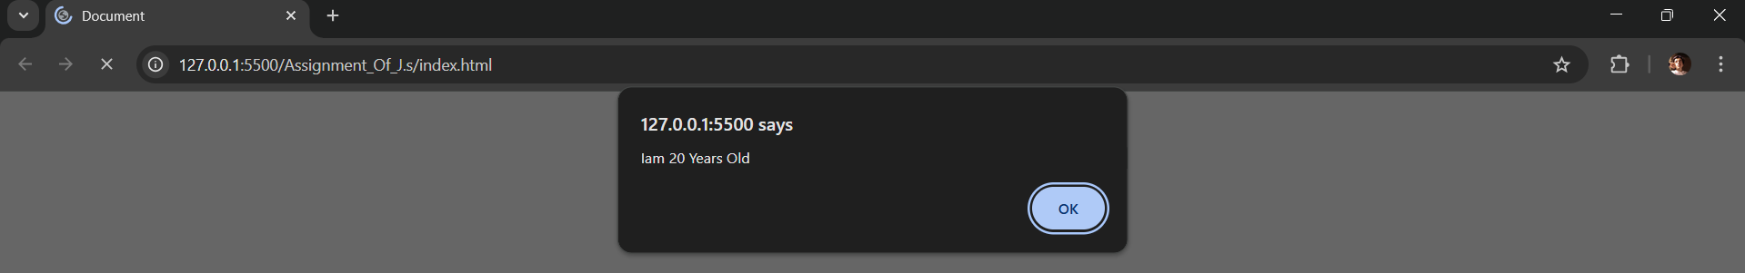

TASK #02
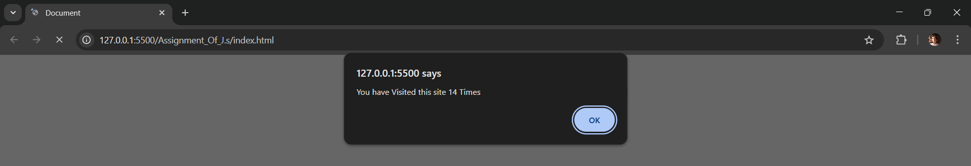

TASK #03
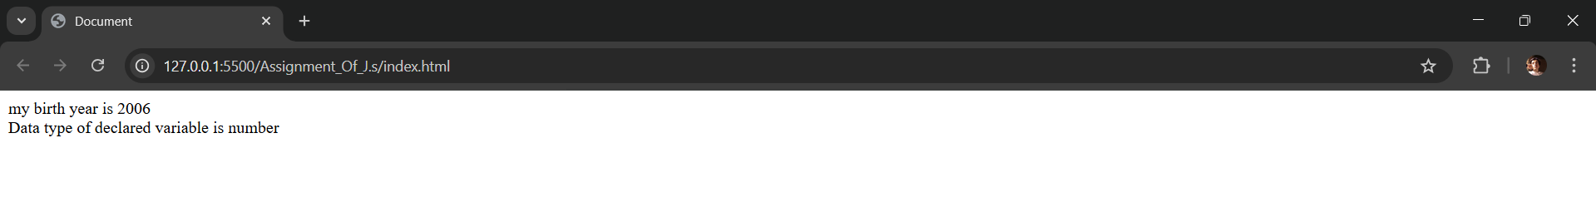

TASK #04
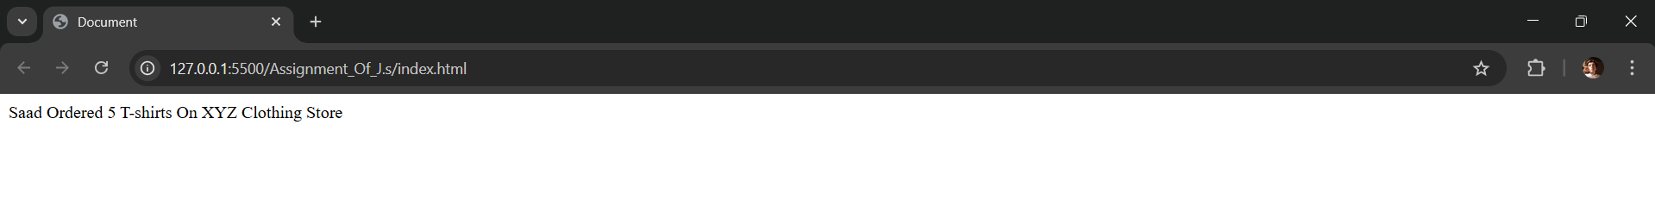

Chapter#04

TASK #01

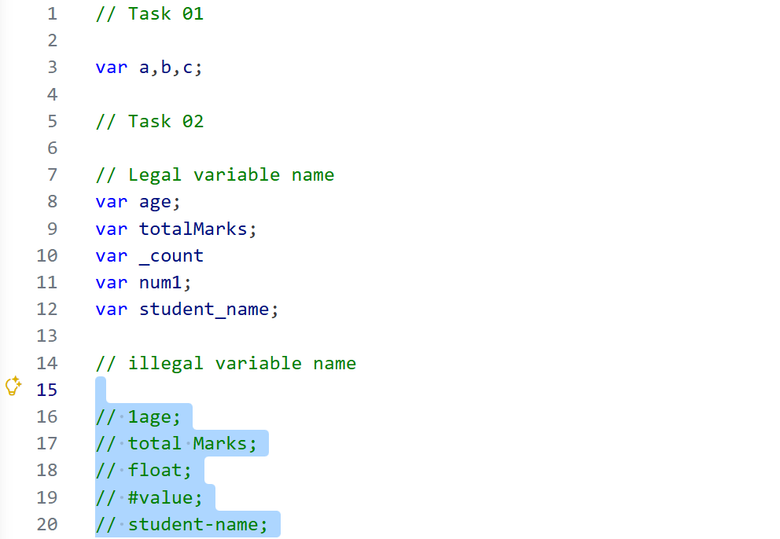

TASK #02


TASK #03


TASK #04

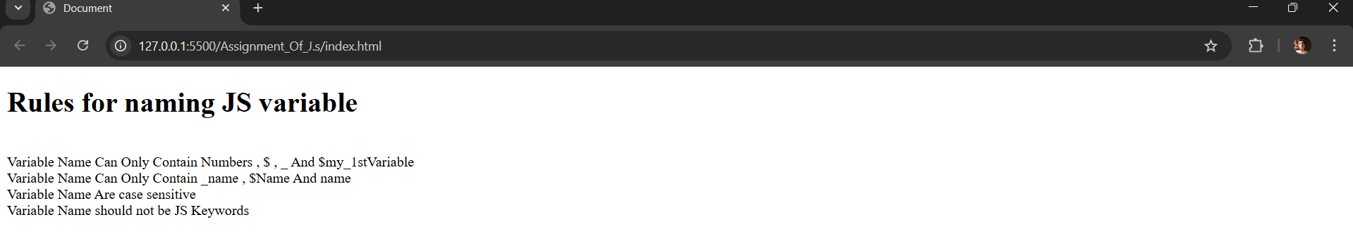
Chapter#05

TASK #01
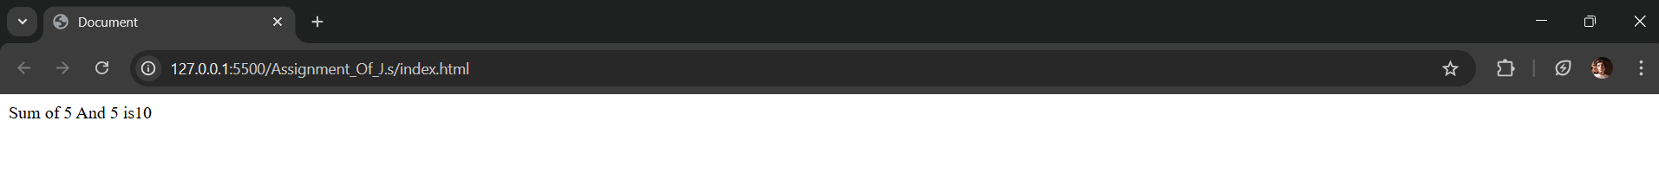

TASK #02
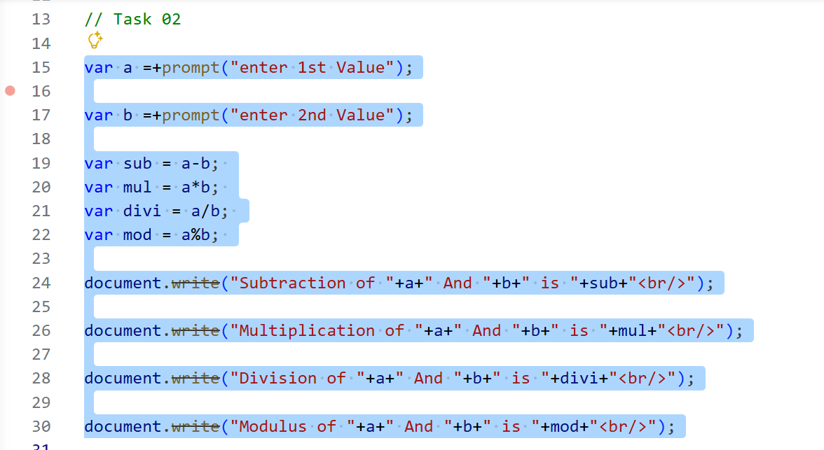
TASK #03

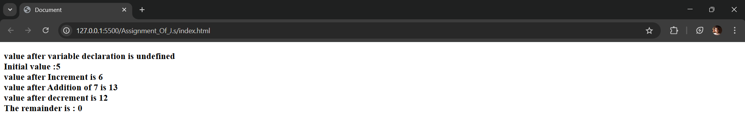

TASK #04

